Configuring and Using the DDR2 Memory on the Nexys 4 DDR/Nexys A7 FPGA Trainer Board using Vivado

Unlike the block RAM resources internal to the FPGA which can be easily instantiated into a design or implicitly added by the synthesizer, DDR memory generally requires the use of IP to properly manage the refresh, precharge, calibration parameters, etc. required for successful memory transactions.

Xilinx provides such IP for their FPGAs, and this guide shows how to properly configure their Memory Interface Generator IP for the specific DDR2 memory IC on the Nexys board. Additionally, an example module is provided demonstrating the use of Xilinx’s MIG IP.

This guide was written against Vivado 2018.3.1 containing MIG IP v4.2. Future versions should be compatible although Xilinx has been known to change the behavior of signals without changing their names/interfaces. In fact, if you need to consult the documentation on the MIG, be careful that the document matches the exact version of the MIG IP. This has caused unnecessary confusion and subtle bugs in the past.

Generating the Memory Controller IP

The example project already has a MIG configured for the Nexys board, but if you wish to re-generate it or create one in a difference project, here's a walkthrough. Begin by opening the IP catalog under the Project Manager:

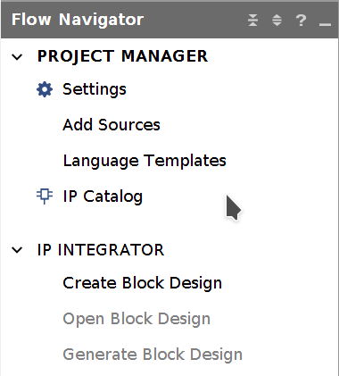

Open the Memory Interface Generator:

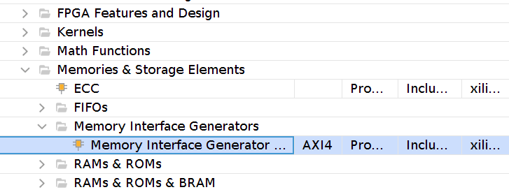
Select "Create Design" and give the module a memorable name (this is the name you will use to instantiate the module in your HDL). Additionally, "AXI4 Interface" should be disabled so that we can work directly with the memory controller's "user interface":

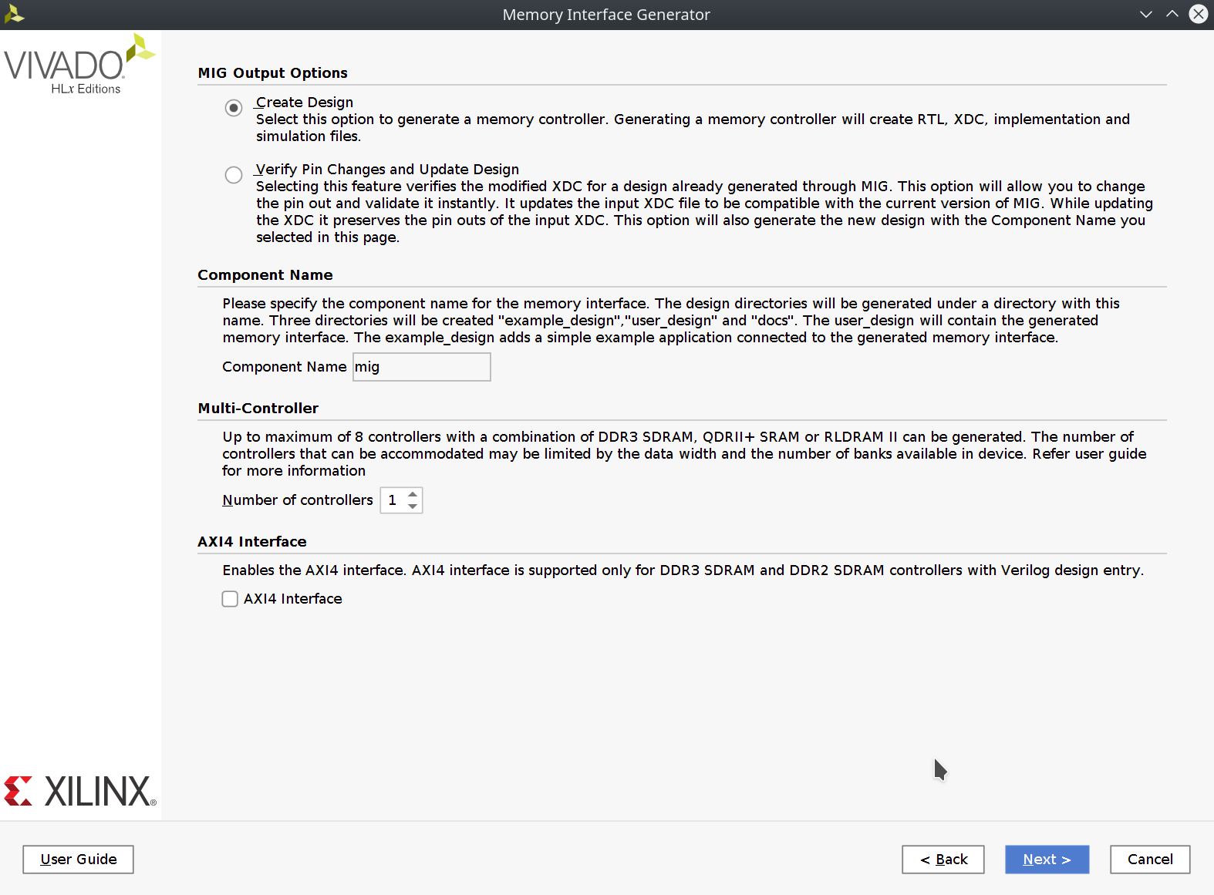

The target FPGA should already be selected from the enclosing project (Which is the
xc7a100t-csg324-1). No additional pin compatible FPGAs should be selected here. Generally these settings are useful if it's possible your project may need to move to a different FPGA down the line, but as the hardware is fixed, it is unnecessary:

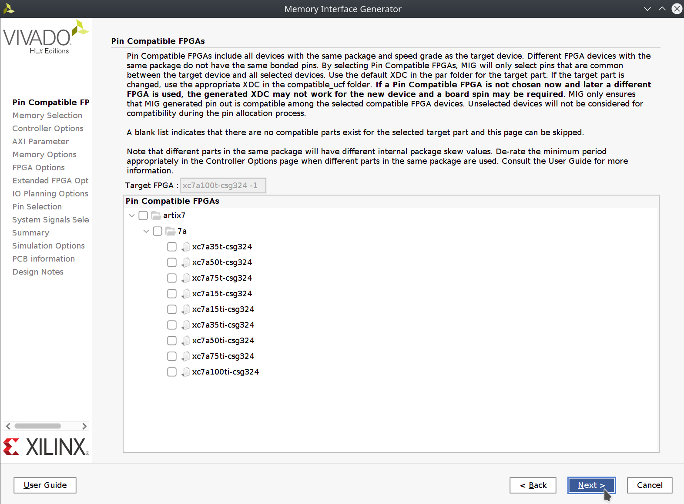

Select DDR2 SDRAM:

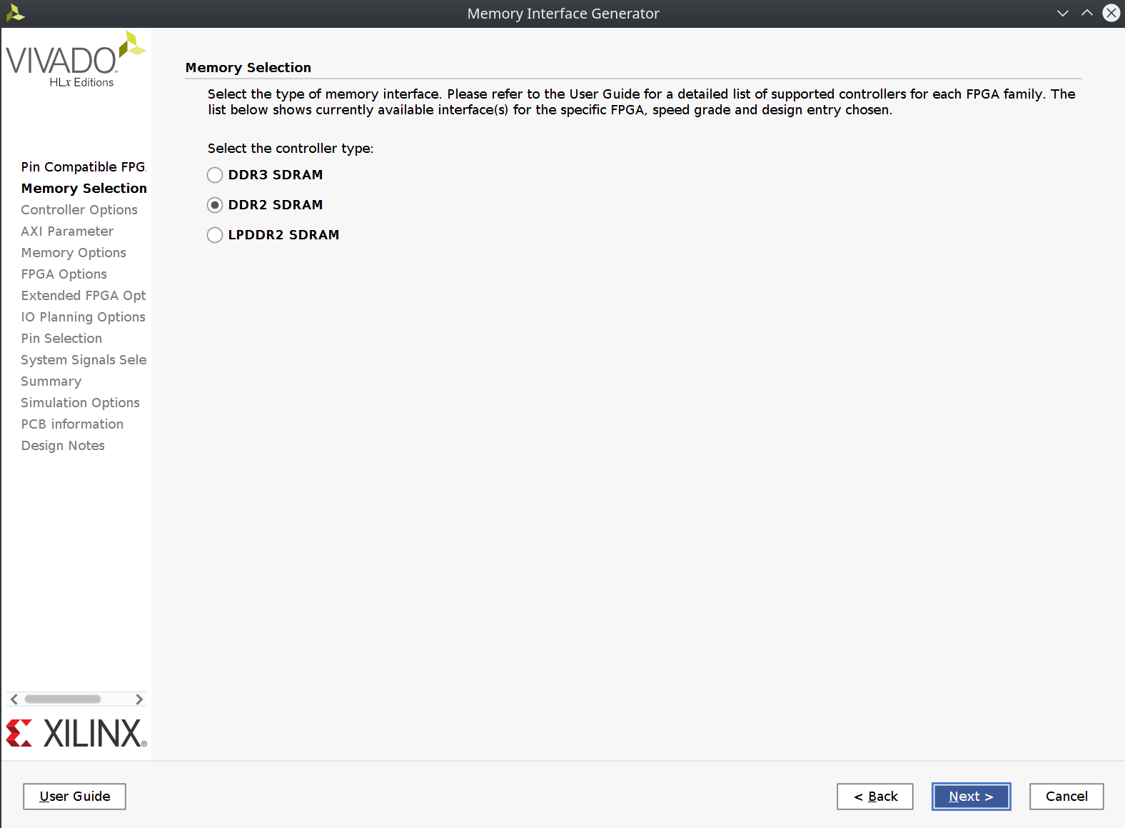

Select a clock period of 3333 ps (300MHz), with a PHY to Controller clock ratio of 1:2, a memory part of MT47H64M16HR-25E (the chip on our board), a data width of 16-bits, data mask selected (allowing us to perform less than full-width transfers), and strict ordering.

While most projects will probably tolerate Normal ordering where the IP is allowed to re-order already queued transactions for speed reasons, Strict ordering may be required for certain access patterns and is the safer option without knowing the application:

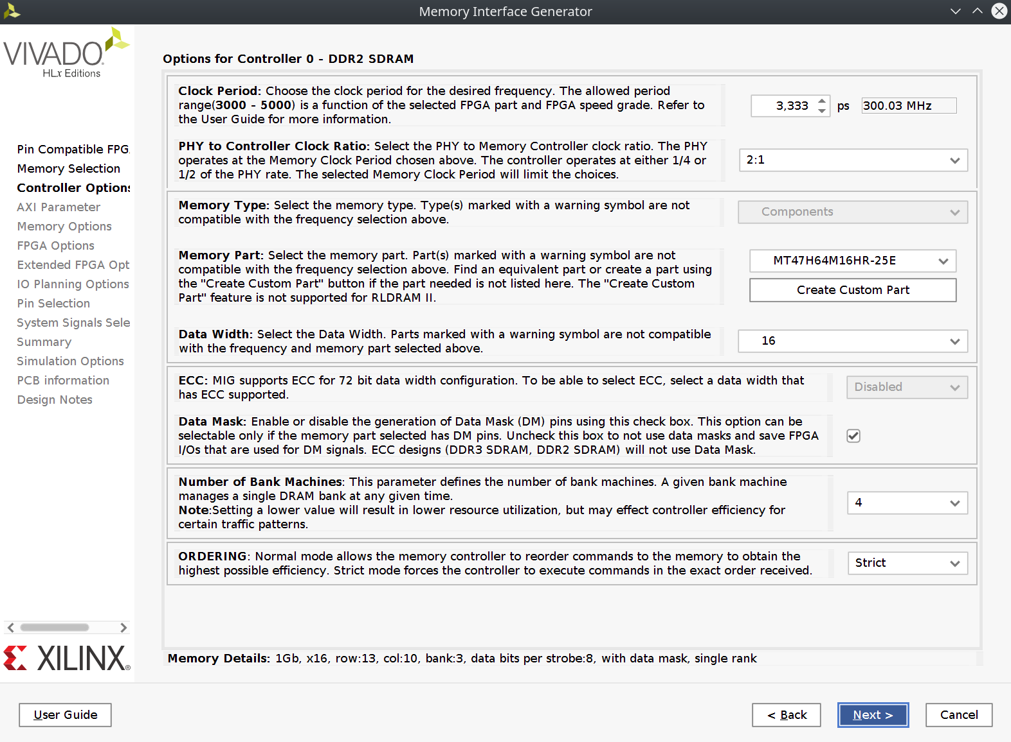

The MIG will internally instantiate one of the DCM/PLL blocks to generate the memory clock. Here, we need to tell the IP generator what the input clock is into that PLL. Other parts of MIG operate directly from a reference clock, which needs to be either externally provided or tied to the input clock at a fixed 200MHz. We will generate a 200MHz input clock elsewhere and later attach it to the reference clock input, so select 5000 ps here. The RTT should be set to 50Ohm, and the other options are configured as seen:

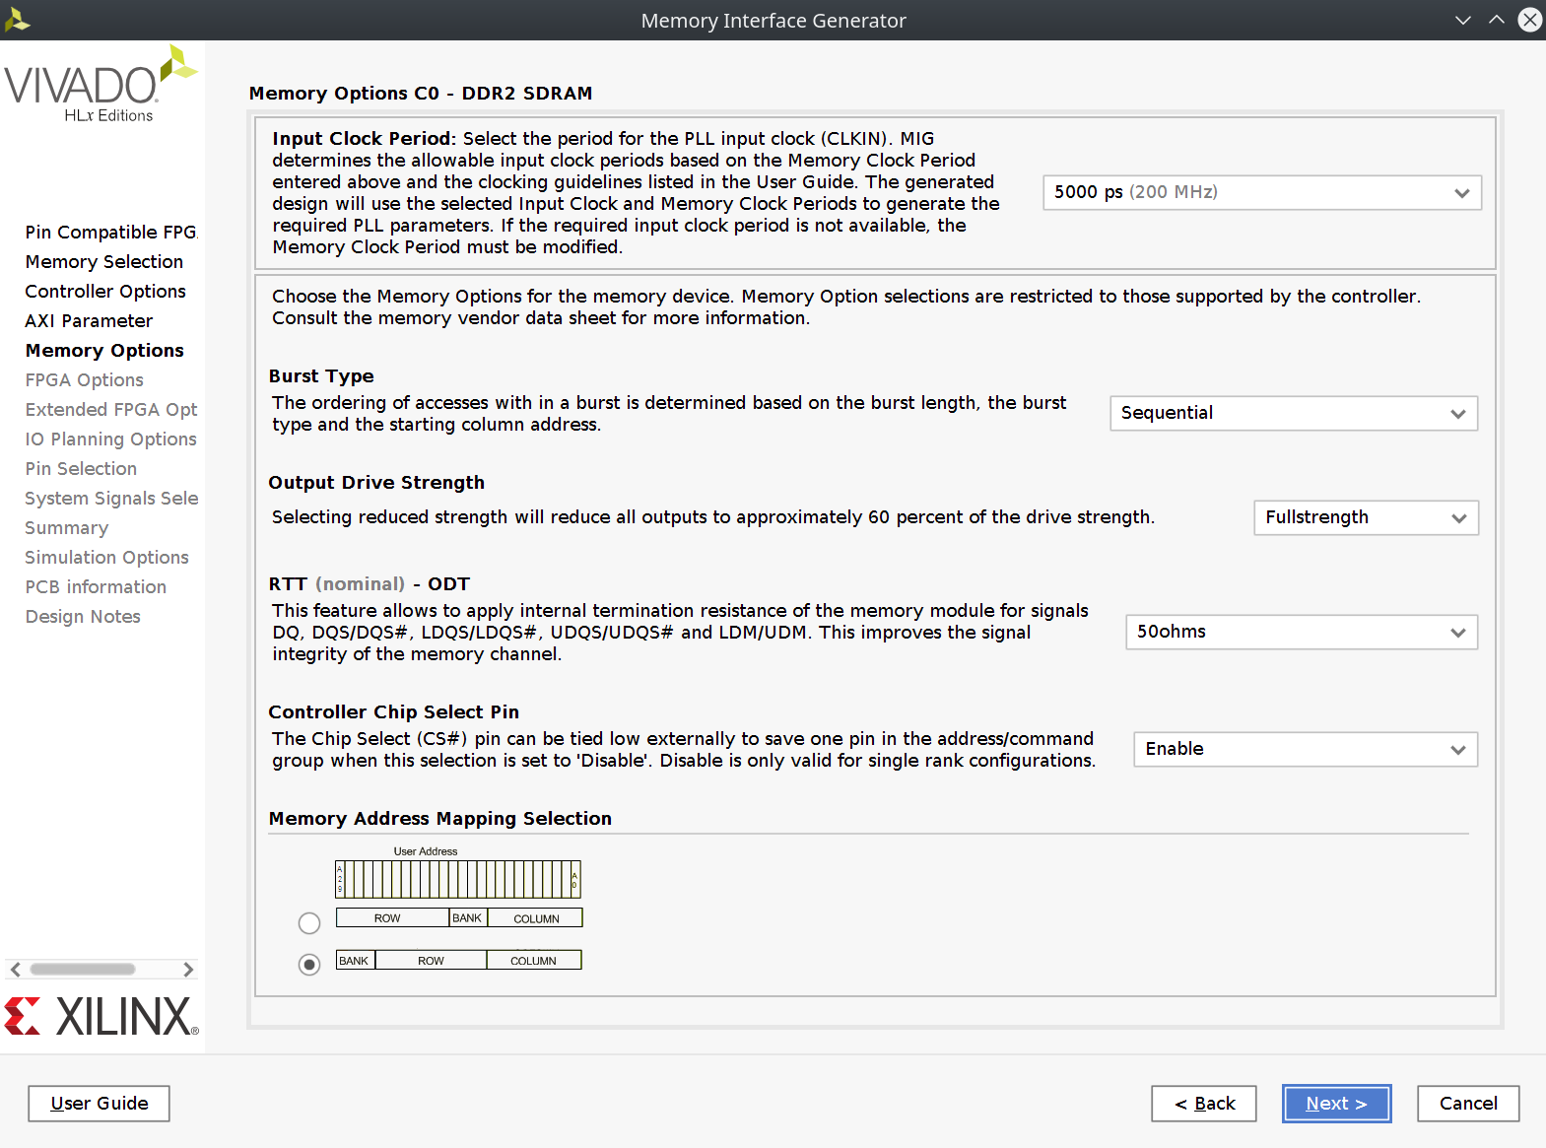

Here we setup the IP for our particular clock and reset style, tying the reference clock to the "system clock", which is the previously mentioned input clock. Be sure to set the other configuration options as well:

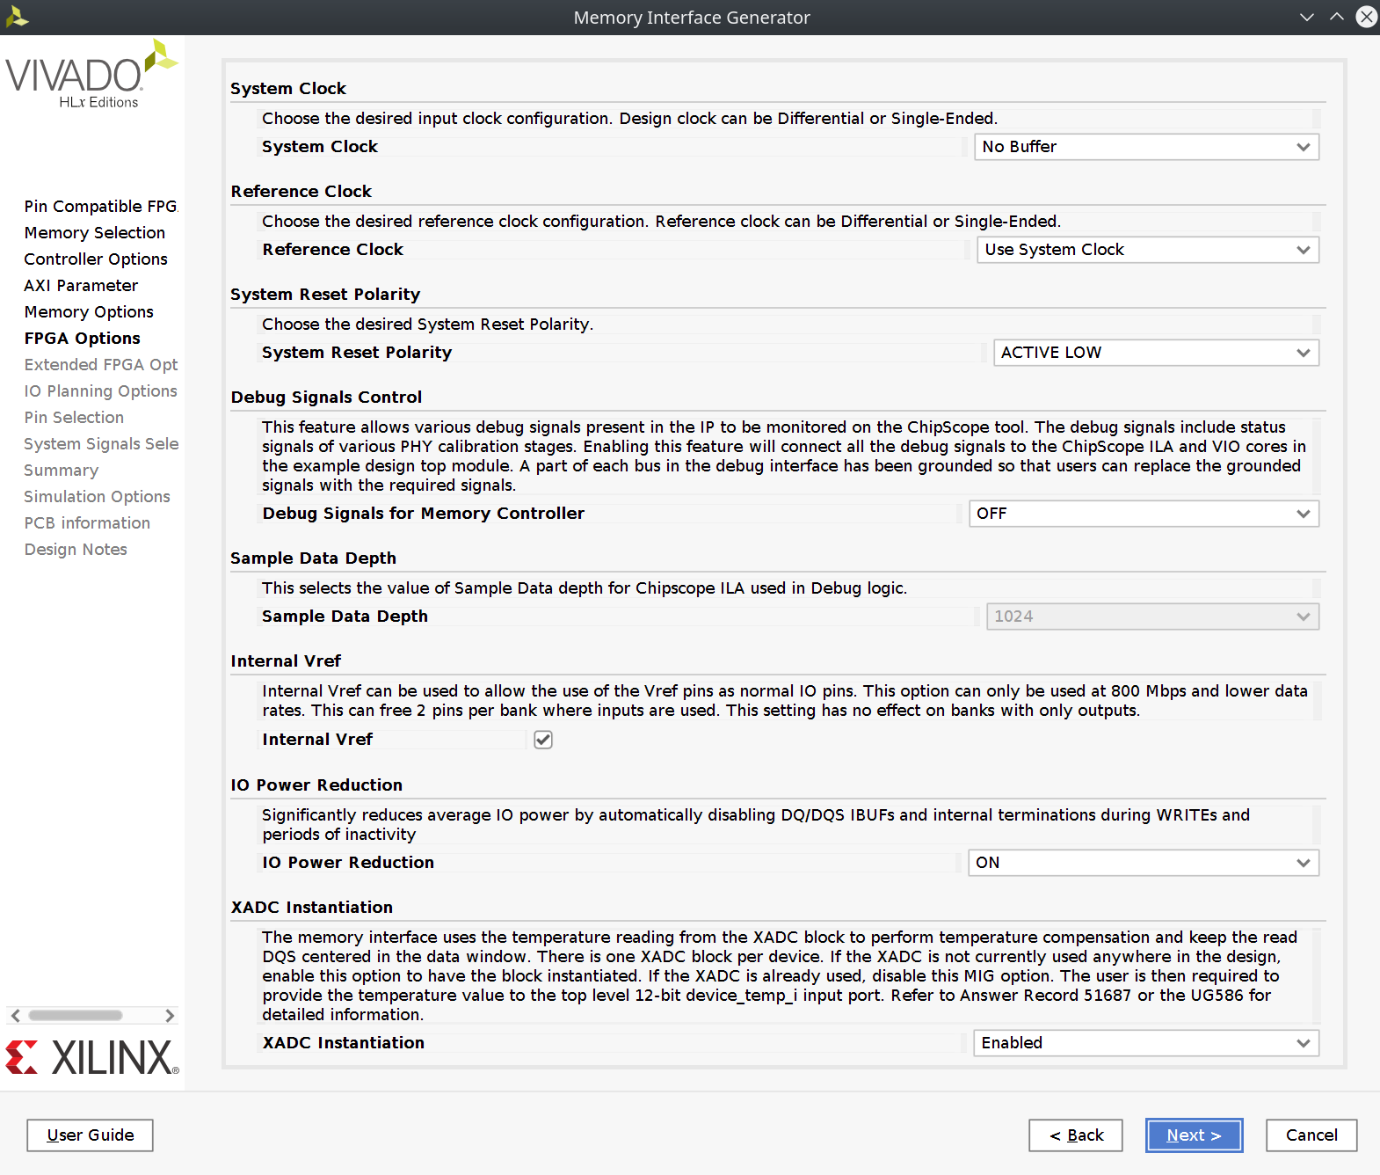

Termination should be set to 50Ohms:

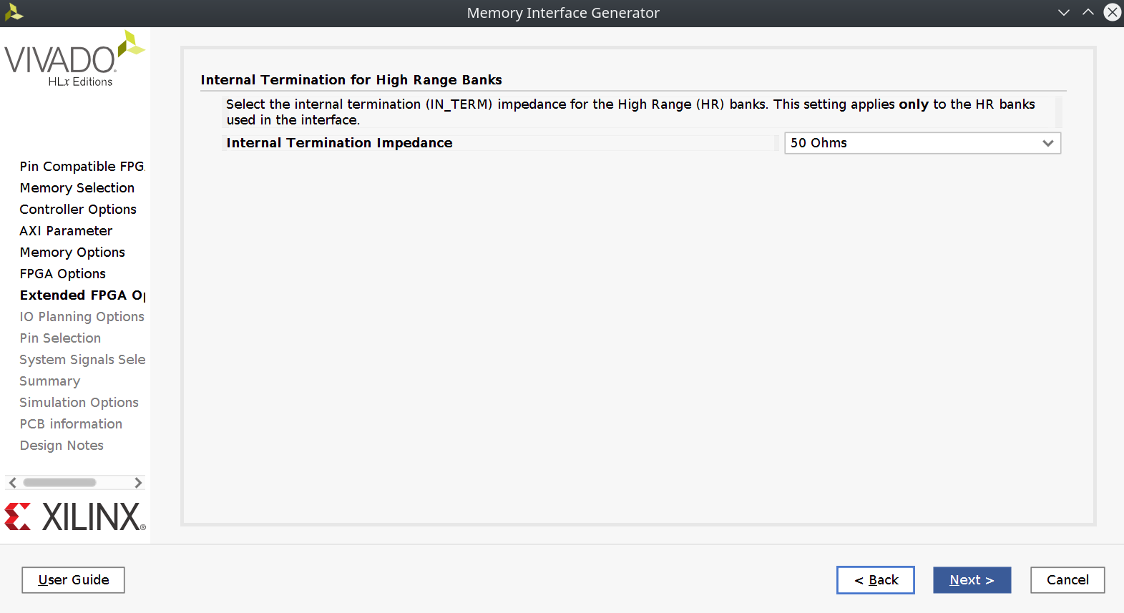

Given that our hardware is already designed and assembled, we need to tell the IP generator exactly where all the various DDR2 pins are located using the Fixed Pin Out option:

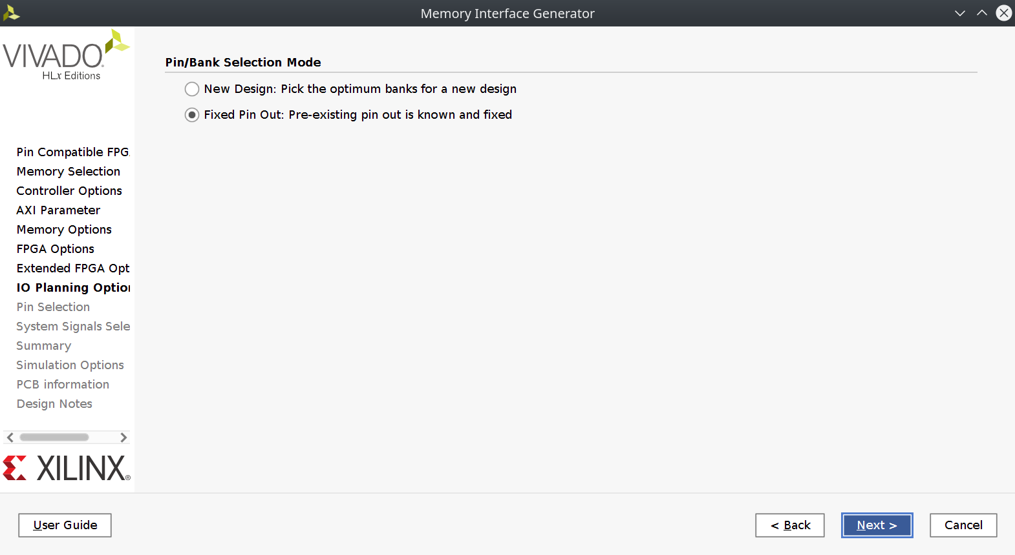

Now load the provided "mig.ucf" file using the Read "XDC/UCF" button, and press "Validate". The IP tool should respond that the pinout is valid. Since we've loaded the desired pins for the DDR memory controller, we no longer need to specify anything about those signals in our overall project constraints file. The MIG IP itself will generate supplemental constraints containing the location, name, jitter, etc. about those nets automatically:

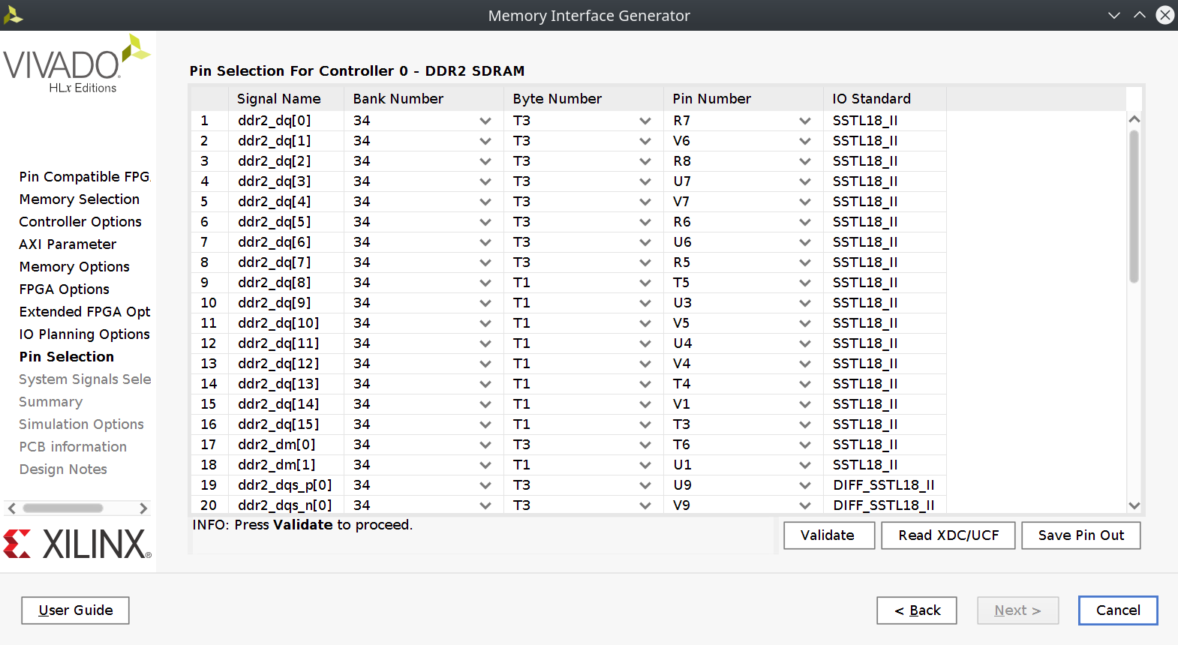

The IP tool will offer options to route status lines to physical pins if desired, but we can set them all to "No connect". They are internally available regardless:

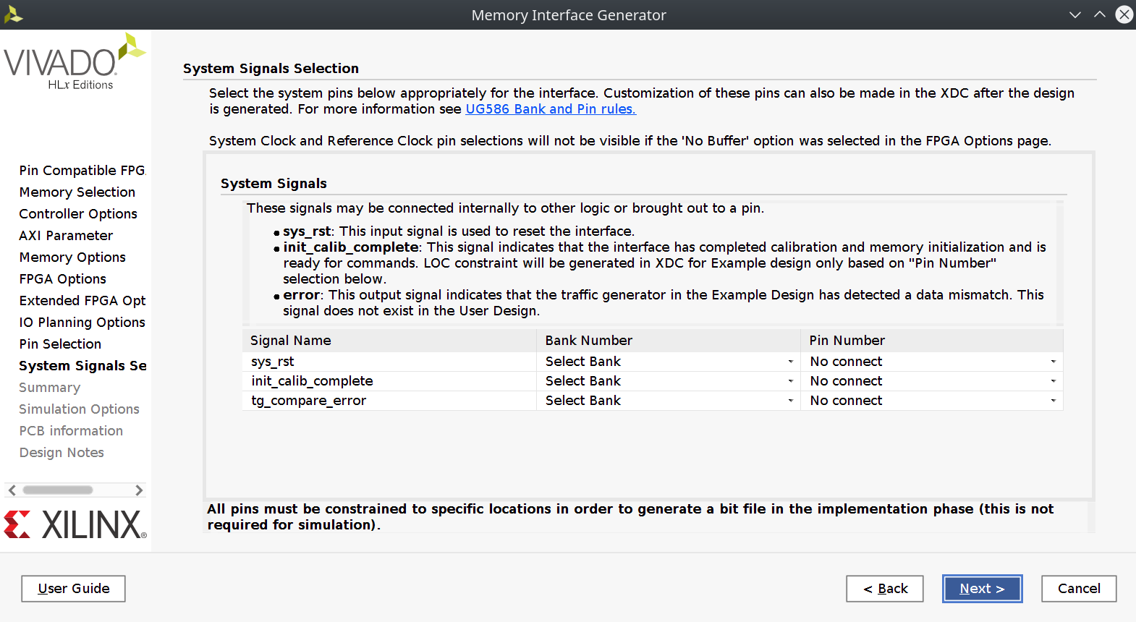

Finally, a summary is available. It is not necessary to agree to the simulation agreement as the built-in simulation model of our specific DDR2 IC is out-of-date, (a more up-to-date model from the manufacturer is provided as part of this project).

Finishing out the IP tool, Vivado should prompt you to generate output products for the IP block with your configuration, which should be done now:

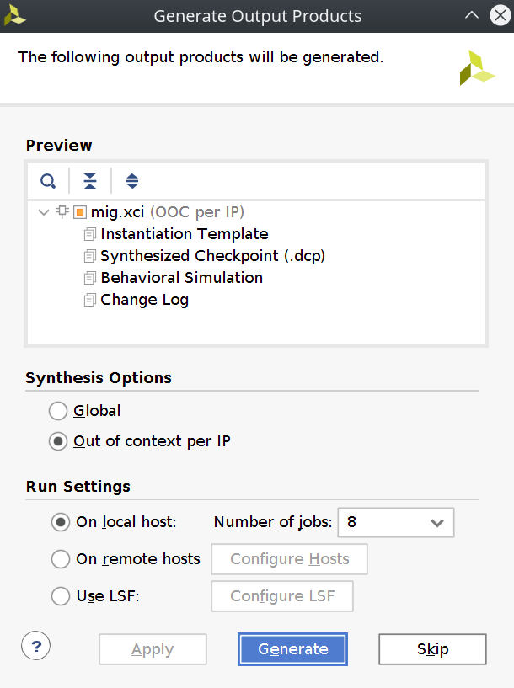

After some time the block should appear in the hierarchy with the name you initially gave it:

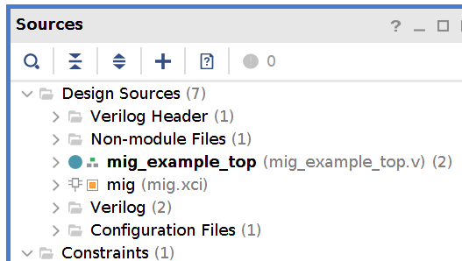

About the Controller
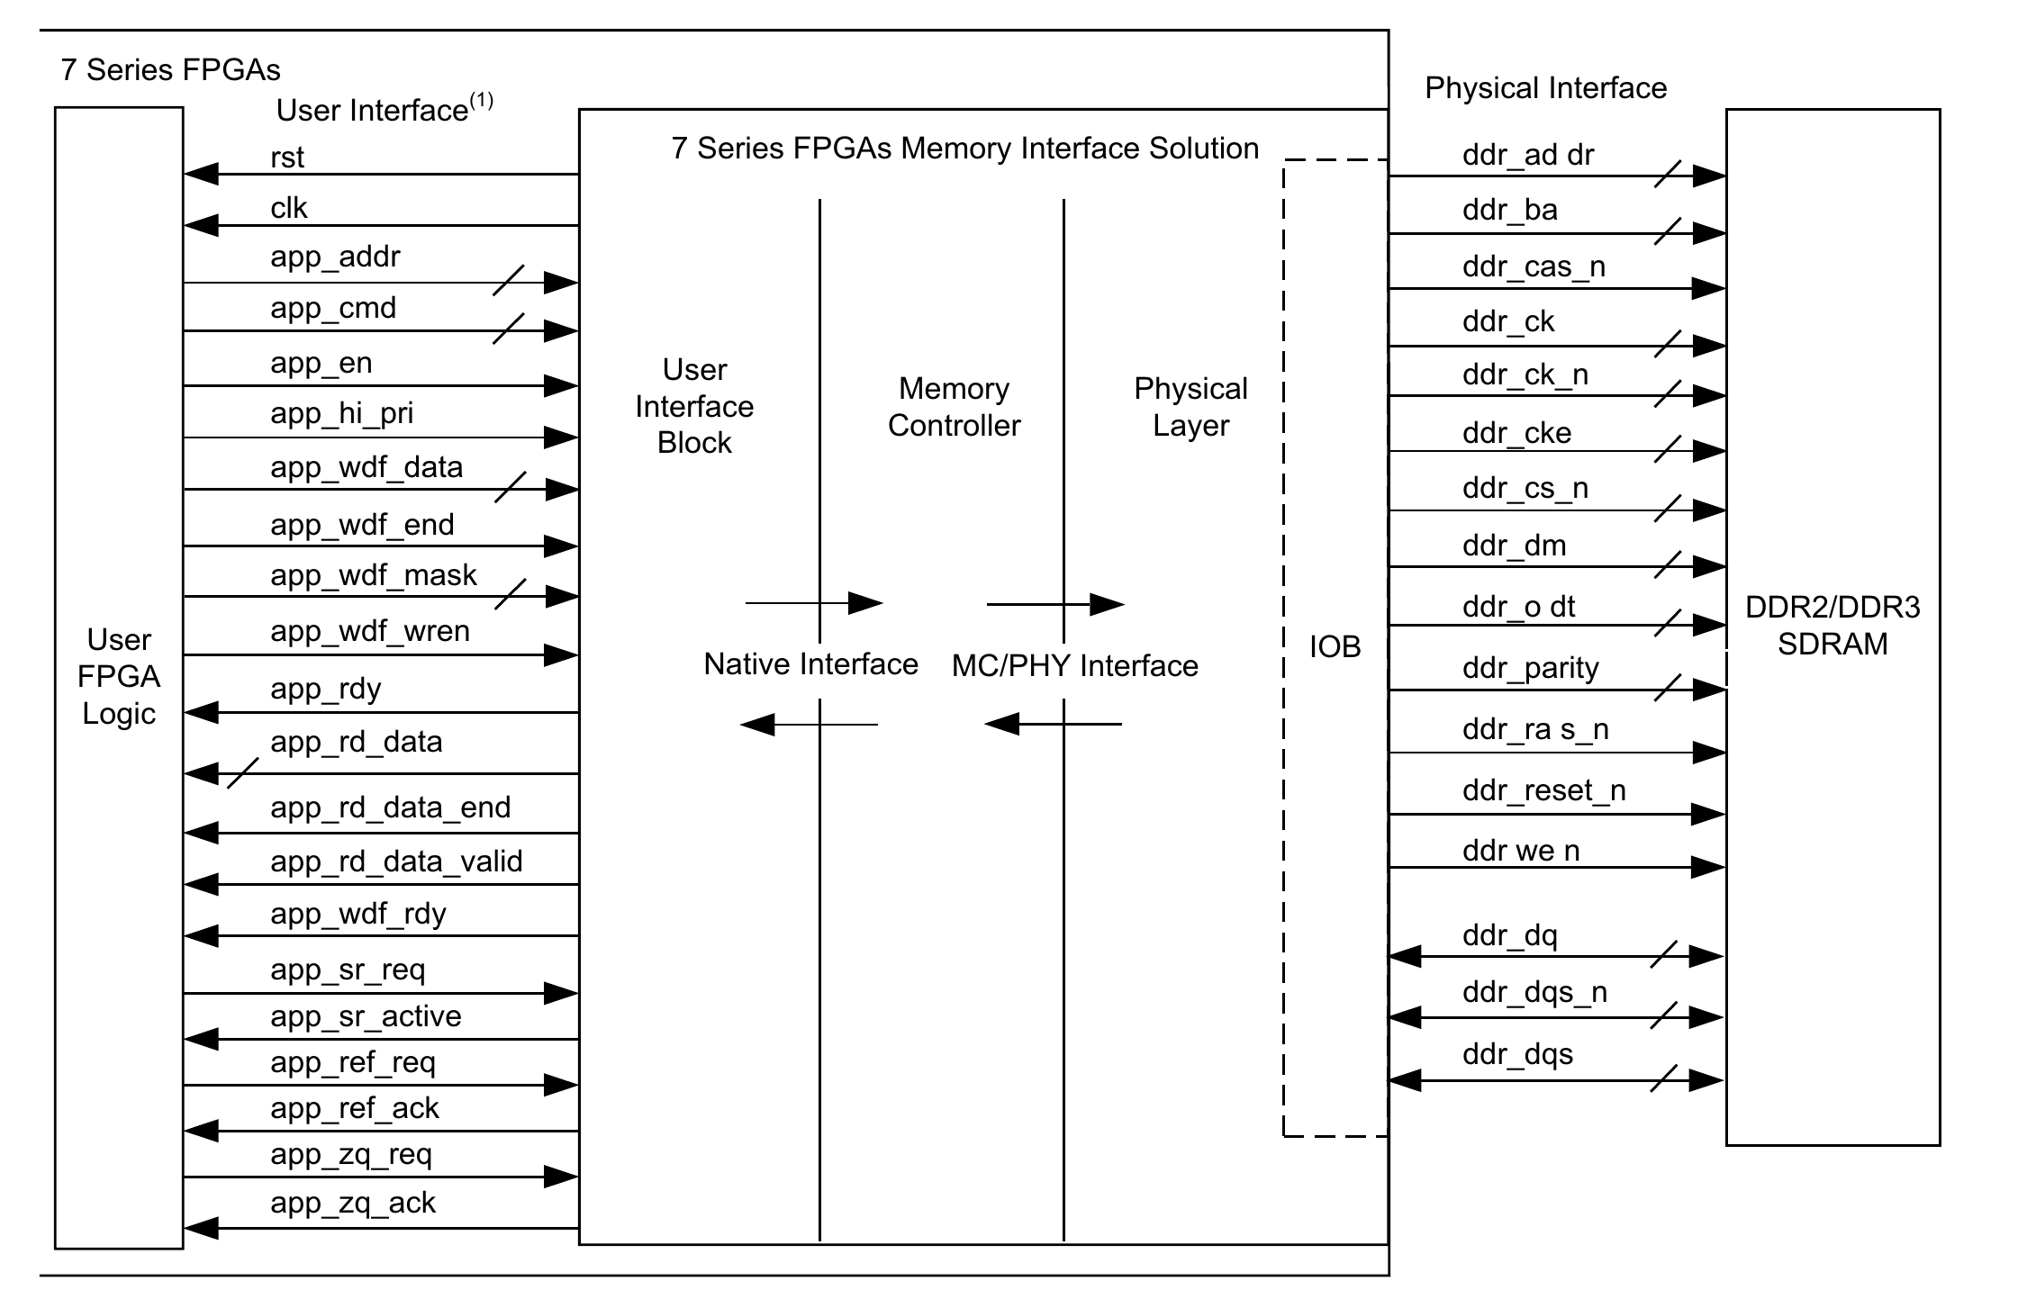
As noted on this excerpt from the official documentation, the MIG IP block has two sets of signals, physical interface signals connecting to the DDR IC, and those providing the abstract memory interface, facing the rest of the logic in your design.

The physical interface signals need to be passed through the levels of hierarchy to the top file. While not strictly necessary for the physical implementation (the MIG IP can generate its own IO buffers), it is required for simulation. That way, a sim top file can connect the "physical" interface signals to the simulated memory module and allow for end-to-end testing.

Some Notes on the MIG's Interface

The MIG exposes a command queue, accepting or providing data according to its internal state machine, whose status is exposed through the various valid and ready flags. Read and Write transactions are initiated by the user via the app_cmd and app_en signals. In general, the MIG signals the receipt of input commands/data, and it is the responsibility of the user application to wait until those commands/data are acknowledged as seen in the following excerpt from the docs:
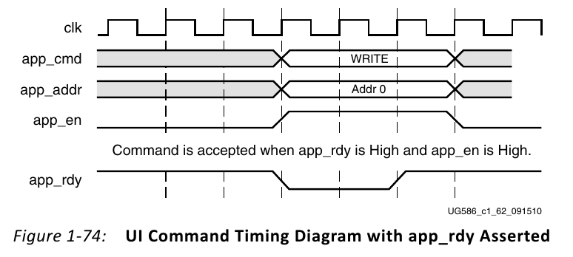
This paradigm lends itself to a simple state machine, sending the appropriate read/write command then waiting for readiness before sending the address and optional data words. Another excerpt from the documentation shows an idealized read transaction:
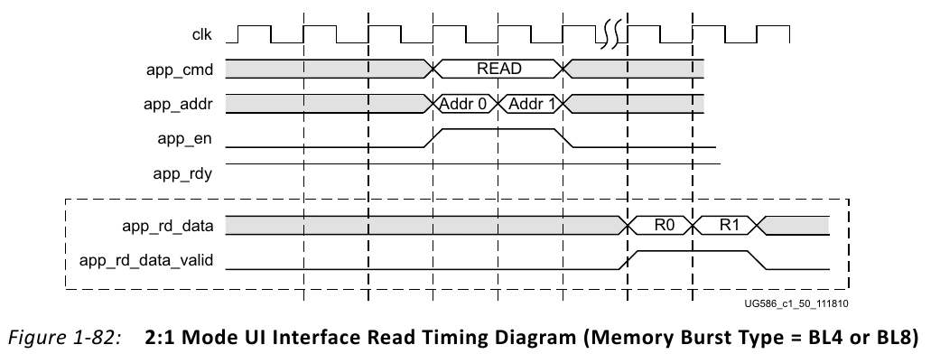

The Xilinx documentation covers this in great detail under the "User Interface" heading of the "Interfacing with the Core" section in Chapter 1.

A More Complete Example

While there is an interface example project accessible by right clicking on the MIG IP module in the hierarchy and selecting "Open IP Example Design", it is somewhat underwhelming and doesn't particularly explain how to use the MIG nor does it handle common use cases. The module's interface is provided in the Verilog and VHDL stubs located at <project>.srcs/sources_1/ip/<mig_name>/mig_stub.(v|vhdl)

To accelerate future projects hoping to use the memory interface, and to provide a concrete example, this project (mig_example) was created containing a strobe-oriented SRAM-like interface to the MIG IP in mem_example.v.

Although the underlying MIG IP supports queuing several reads and writes in a burst, the synchronous access style of mem_example is intended to perform a single read or write as an atomic operation. Additionally, as mem_example was adapted from part of a larger project, it can synchronize signals from the "cpu" clock domain into the memory controller's "mem" clock domain.

This synchronization occurs only on the operation/status strobes and requires that addr, data_in and width input signals remain stable from assertion of rstrobe/wstrobe until transaction_complete is returned.

As an additional effect, the "mem" clock must run at least 3 times faster than the "cpu" clock. While using asynchronous FIFOs would eliminate both of these limitations, in keeping with the general theme, flag synchronizers are used for their simplicity. Again, these are limitations in the mem_example.v module and not the underlying Xilinx MIG IP.

The synthesizer generally does a good job detecting the false timing paths that exist between things like data_in changing in the cpu clock domain affecting things in the mem clock domain. That being said, it was still necessary to examine and cut a handful of false paths which can never occur given how we guard against changing those signals using flag synchronizers.

Let's look at our overall simulation:

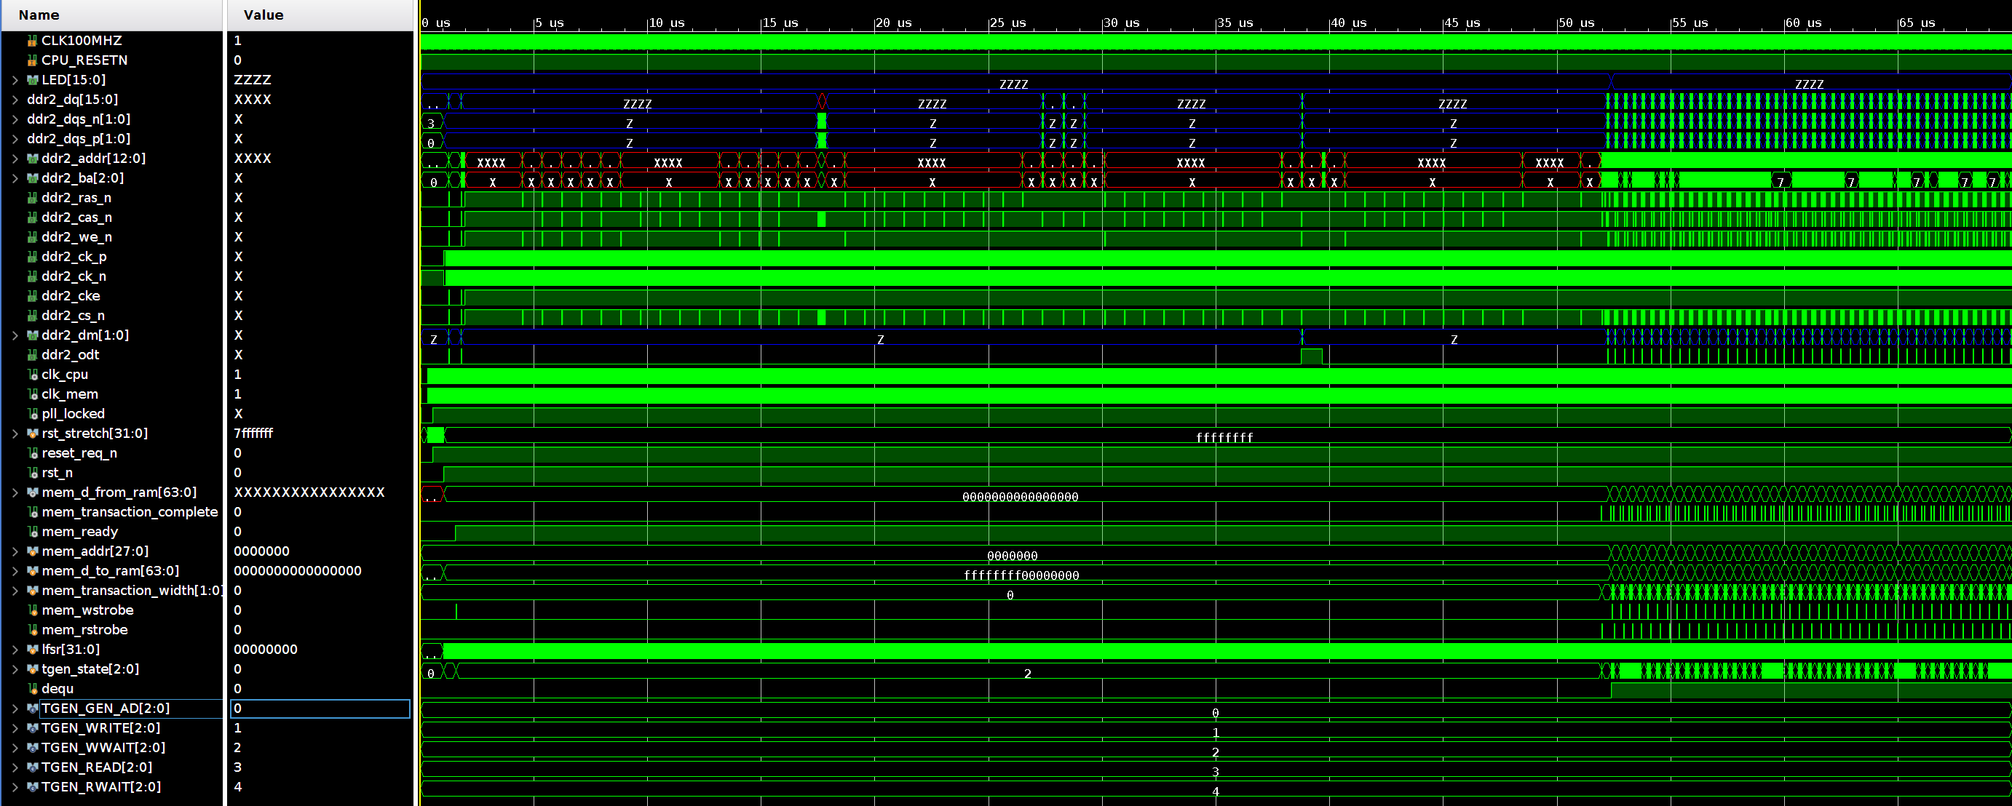

Two things you may initially notice: first there is a large delay during the simulation where only occasional memory accesses occur. This is due to the MIG IP's training process which calibrates against the DDR2 model on reset, just like in the physical implementation. Even though this is a simulation, an abbreviated version of the calibration still occurs and cannot be disabled. Fortunately this calibration is reduced from the order of several ms in real hardware down to ~65us during sim.

Next the tgen_state indicates that we are in a write transaction for an extended period of time. This is entirely expected. We have requested that the memory performs a write, and even through the MIG IP reports ready, it will delay completion of the transaction until the memory becomes available. As a result, the first write is stalled.

Now to examine one of the memory transactions:

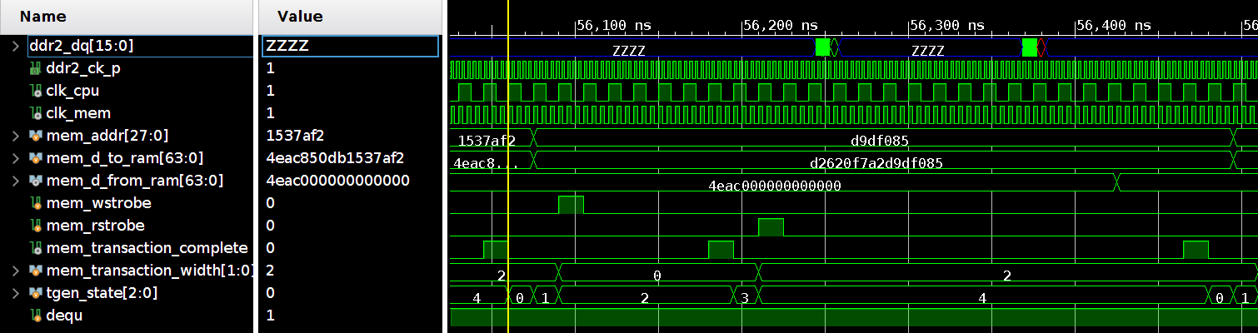

A randomly generated address along with data is generated from an LFSR. These values are captured and fed to the memory interface for a 64-bit write. We wait for the write to be accepted via transaction_complete (notice how quickly this occurs, as the MIG IP signals acceptance before it makes it to RAM visible by the relationship of transaction_complete to ddr2_dq).

Detail of the write:

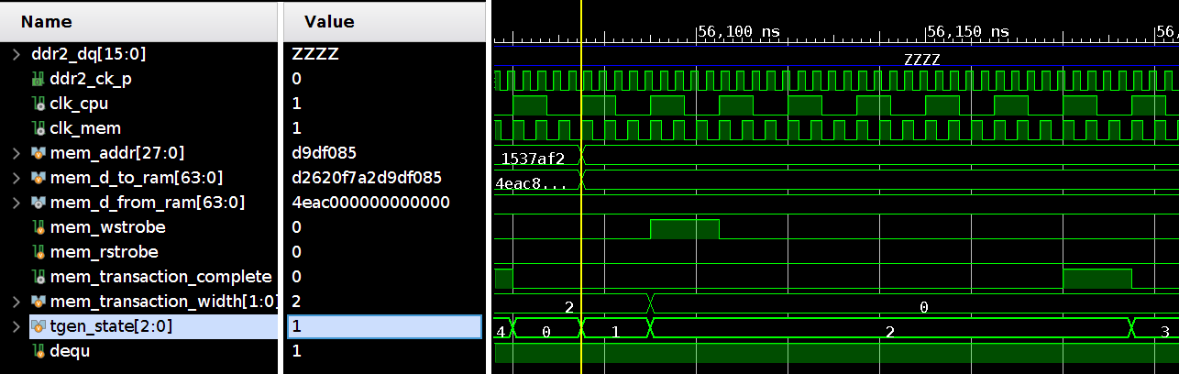

Next we make a 16-bit read from the same address:

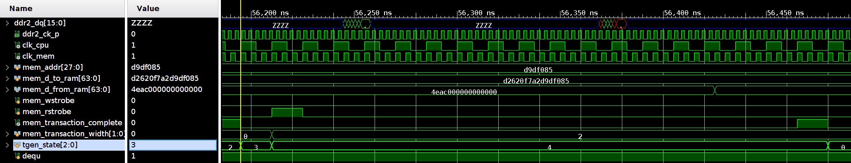

Once this read finishes, we compare the data returned with what was originally written. If it matches, LED[0] is lit via the dequ signal.

You may notice the odd "left justification" of bits when performing less than 64-bit transactions. The mem_example memory interface was adapted from a big-endian processor design where this arrangement simplified integration with other memory mapped peripherals. It can be changed or just accounted for when using the module. Still, mem_example will allow for byte-oriented addressing into memory with 8, 16, 32, or 64 bit reads and writes.

If all goes well during synthesis, running the example on a real board will result in LED[0] being lit almost immediately after reset. The LED will stay lit as long as the results from the DDR2 read match what was written.

